Raphael Bitton
Prof. Sasso
SOSC 133
30 May 2025
Wings of Unrest: The Relationship Between Global Flight Connectivity and Social Instability
Abstract
This study investigates the relationship between air connectivity and social unrest across a global dataset of 2,620 cities. Using a Negative Binomial regression model, we explore how factors related to air travel, particularly the number of flights, correlate with the frequency of unrest events, while controlling for demographic, socioeconomic, and geographic variables. The results reveal that increased air connectivity is significantly associated with a higher number of unrest events (p < 0.001). Other key predictors include population served, unemployment rates, and freedom of expression, all of which are positively associated with unrest, whereas Human Development Index (HDI) and land area exhibit negative associations. The model explains approximately 32% of the deviance (Pseudo R² = 0.323), suggesting a moderate explanatory power. These findings imply that while air connectivity can be a vector for economic growth and openness, it may also facilitate the spread or concentration of dissent, necessitating more nuanced transportation and urban planning strategies.
Introduction
In the contemporary era of globalization, cities have become more than just population centers; they are nodes in a vast international network of people, ideas, and capital. Among these, globally connected cities, those with extensive air travel networks, often stand out not only for their economic dynamism but also for their political turbulence. From Paris to Hong Kong, such cities frequently appear in headlines for mass protests, civil demonstrations, and other forms of unrest. This recurring pattern raises a fundamental question: does global connectivity increase a city's likelihood of experiencing social unrest?
Despite growing interest in how globalization affects domestic politics, relatively little empirical research has investigated the role of international air transportation networks in shaping urban political dynamics. Air connectivity is more than a symbol of status or economic opportunity; it facilitates mobility, accelerates the diffusion of information and norms, and increases a city’s visibility on the world stage. These characteristics may in turn shape the conditions under which unrest arises. Specifically, greater mobility may enable broader protest coordination by allowing people, ideas, and tactics to move more easily between cities; global visibility may incentivize symbolic protest actions intended to attract international media attention; and economic integration may deepen inequality or expose cities to global shocks, amplifying grievances and mobilizing discontent.
This project explores whether cities with greater flight connectivity differ systematically in their levels of protest activity compared to less connected urban areas. Using a cross-sectional dataset and categorizing cities by connectivity tier, the study compares protest frequency across groups while controlling for key confounding variables such as GDP per capita, population size, education level, and regime type.
The contribution of this paper is twofold: first, it introduces air connectivity as a measurable and underutilized indicator of global integration in urban political research; second, it offers a transparent and scalable design for testing this relationship using publicly available data. While not seeking to establish causality, the study highlights a novel link between global infrastructure and domestic instability.
Literature Review

Globalization, International Integration, and Urban Political Dynamics
Scholars have noted that globalization significantly shapes urban political contention. Increasing political globalization, such as stronger ties to international organizations, has been found to expand protest activity in democracies, while economic globalization sometimes has a dampening effect [1]. Globally networked cities frequently become focal points for dissent, exemplified by protests such as those in Seattle against the WTO and Porto Alegre’s social forums, which symbolize global social movements [2]. Köhler and Wissen describe this phenomenon as the "glocalization" of protest, highlighting how urban conflicts resonate across global networks [3]. Similarly, cities highly integrated into global neoliberal policies have historically witnessed increased protests against austerity measures and structural adjustments imposed by institutions like the IMF and World Bank [4], [5].

Infrastructure, Mobility, and Protest Visibility
Critical infrastructure networks, particularly air travel, facilitate the diffusion of protests and increase their visibility. Historical examples like 19th-century railroad and telegraph expansions illustrate how transportation networks accelerate protest diffusion [6]. Today, air travel connectivity allows activists from various countries to converge physically in host cities for international events, amplifying protests’ global visibility [5], [7]. Notably, during Hong Kong’s 2019 pro-democracy protests, the strategic occupation of the city’s international airport significantly raised international awareness of local grievances [8]. Airports thus act as nodes that enhance the rapid global dissemination of protest-related information [9].

Regime Type, Democratic Accountability, and Global Exposure
Regime type significantly mediates the relationship between global exposure and urban unrest. Democratic regimes often see protest as a normal political feature due to guaranteed civil liberties [1], [10]. Varieties of Democracy (V-Dem) data highlights that pro-democracy mobilizations peak in hybrid regimes, with democratic contexts typically providing better mechanisms for managing grievances peacefully [11]. Conversely, authoritarian regimes frequently perceive global exposure as threatening, prompting restrictive responses such as limiting foreign NGO activities and imposing internet shutdowns [12], [13]. Keck and Sikkink’s “boomerang” model explains how activists in authoritarian contexts leverage global networks to exert external pressure on repressive governments, occasionally inciting urban unrest when regimes attempt to isolate themselves further from global influences [14], [15].

Air Connectivity and International Mobility in Empirical Research
Empirical studies increasingly utilize measures of air connectivity and international mobility to analyze urban unrest. The World Bank’s Air Connectivity Index, which measures integration into global airline networks, serves as a valuable indicator correlating strongly with globalization markers [16]. Cross-national analyses find correlations between global economic integration indicators, such as IMF loans, and increased anti-regime protest frequency [17]. Qualitative case studies, including ethnographic accounts of climate activism, reveal how activists coordinate transnational protests through international mobility facilitated by air travel networks [18]. Furthermore, the rapid global diffusion of protest techniques highlights the strategic importance of air connectivity for contemporary urban activism [6]. These varied methodological approaches collectively demonstrate that air connectivity significantly impacts urban protest dynamics by enhancing mobility, coordination, and visibility on the global stage [7], [8].

Data Source and Collection
This study utilizes a comprehensive cross-sectional dataset derived from multiple publicly accessible sources to analyze the relationship between global flight connectivity and social unrest in major cities. Air connectivity data were sourced from OpenFlights specifically detailing direct flights associated with each city's airports in 2014. Social unrest data were extracted from the Armed Conflict Location & Event Data Project (ACLED), capturing politically motivated protests, demonstrations, and riots between June 2020 and April 2025.
Additional socioeconomic, demographic, and political data were sourced from authoritative datasets: the World Bank provided GDP per capita, land area, and unemployment rates; the United Nations Development Programme supplied data on the Human Development Index (HDI), life expectancy, and average schooling years; and the Varieties of Democracy (V-Dem) dataset provided measures of civil liberties and governance, specifically the Freedom of Expression and Core Civil Society indices.
The representative population includes cities globally with available and reliable data, focusing on those cities exhibiting varying degrees of flight connectivity and documented social unrest events. The dataset comprises a final sample of cities filtered and aggregated based on comprehensive criteria, yielding a robust analytic sample size.
Data Cleaning and Descriptive Statistics
Following data compilation, a rigorous cleaning was undertaken to ensure analytic consistency across sources. Cities were geolocated and linked to nearby airports using the Haversine formula to calculate great-circle distances. Only airports within a 50-kilometer radius and in the same country were considered. For each city, the associated airport was selected based on a "service score" calculated as the number of departures divided by distance plus one. This allowed for the derivation of a Served Population metric, representing the cumulative population linked to each airport. Protest events were similarly geocoded and mapped to the nearest city under the same geographic and national constraints. These assignments were implemented using efficient batch operations in PyTorch, enabling large-scale processing across thousands of spatial points.
Cities with missing or anomalous population data, or those for which no valid airport or protest match could be made, were excluded from the final dataset. Country names were standardized using a harmonization map, and manually corrected in exceptional cases such as Taiwan. National-level socioeconomic and governance indicators, including the Human Development Index (HDI), unemployment rate, civil liberties, and civil society indices, were merged into the dataset based on country codes, with values assumed to be constant across cities within the same nation due to data availability limitations.
Dataset Overview
The final dataset includes 2,620 cities from 191 countries, assembled from a variety of publicly accessible sources. Each observation corresponds to a unique city and includes a mix of city-level, airport-level, and country-level indicators. City-level spatial attributes were calculated using geographic proximity algorithms, while national indicators were uniformly assigned to cities within the same country. This structure allows for a comprehensive yet scalable cross-sectional analysis of global protest dynamics in relation to urban connectivity.
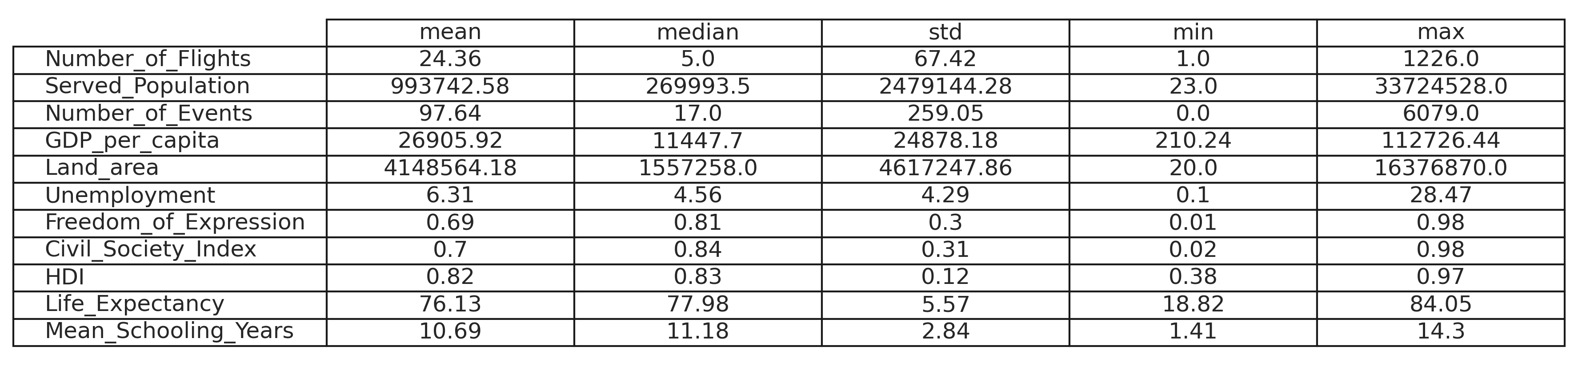
Flight Connectivity
The independent variable, Number of Flights, captures the total number of direct commercial flights associated with each city, aggregated across all airports within a city jurisdiction. The distribution is highly right-skewed, with a minimum of 1 flight and a maximum of 1,226. The mean number of flights per city is 24.4, but the median is only 5, indicating that a small subset of cities function as major global hubs while the majority have relatively modest connectivity. This variable serves as a core indicator of a city's integration into air travel networks and highlights stark disparities in mobility infrastructure across regions.
Social Unrest Events
The dependent variable in this study, Number of Events, quantifies the total count of protest-related incidents geocoded to each city between June 2020 and April 2025. The number of recorded events ranges from 0 to 6,079, with a mean of 97.6 and a median of 17. This large discrepancy between the mean and median points to significant overdispersion, a statistical property appropriately handled by the Negative Binomial regression model used in the analysis. A majority of cities experienced relatively low protest frequency, but a notable minority witnessed extensive unrest, reflecting diverse political climates and governance conditions globally.
Served Population
The Served Population variable estimates the number of people who are effectively connected to each airport, based on a weighted score that considers both proximity and flight volume. Values range from as low as 23 to over 33 million, with a mean of approximately 994,000 and a median of roughly 270,000. The top quartile of cities serve more than 875,000 people, suggesting that while most airports serve small to moderate populations, a few serve exceptionally large metropolitan areas. This metric captures the spatial and functional reach of air transportation in different regions and is especially useful for analyzing infrastructural equity.
City and Country Characteristics
Each observation in the dataset is tied to a specific city, and the dataset includes 2,631 unique city names across 191 distinct countries. These categorical variables provide the geographic granularity necessary for cross-sectional analysis. The most frequently occurring city name is "Santa Rosa," which appears four times in different countries or regions. Country-level variables such as the Human Development Index (HDI), unemployment rate, and indices for civil liberties and civil society strength were merged using national identifiers. These indicators were applied uniformly to all cities within a country due to data availability constraints, serving as contextual controls in the regression analysis.
Empirical Strategy
This study seeks to assess whether global air connectivity contributes to increased social unrest in cities. To test this relationship, I adopted a cross-sectional regression framework, using city-level data on protest frequency as the dependent variable and a range of infrastructural, socioeconomic, and political variables as predictors.
The central hypothesis is that cities with greater air connectivity experience more frequent protest activity. This is premised on the idea that air connectivity increases not only the movement of people but also the circulation of ideas, protest tactics, and global attention. As such, highly connected cities may be more prone to unrest, not necessarily because air travel causes protests, but because it facilitates the conditions under which collective mobilization is more feasible or impactful.
The dependent variable is the total number of protest-related events (Number_of_Events) in each city from June 2020 to April 2025, as recorded by ACLED. As mentioned before, it overdispersed (i.e., the variance far exceeds the mean), making a standard Poisson regression unsuitable. Instead, we employ a Negative Binomial regression model, which relaxes the equidispersion assumption and better accounts for the observed variability. This choice is supported by exploratory data analysis and model fit diagnostics.
The independent variable of interest is:
- Number_of_Flights: a count of all direct flights associated with a city’s nearby airports, serving as a proxy for structural air connectivity.
To account for potential confounding factors, the model includes the following control variables:
- Served_Population: an estimate of the number of people effectively served by the city's airports, weighted by both population and proximity.
- Land_area: representing physical urban scale, which may influence both protest diffusion and airport coverage.
- Unemployment: a key economic grievance often correlated with unrest.
- Freedom_of_Expression: an institutional measure capturing political openness, which may both encourage and enable protest activity.
- Human Development Index (HDI): a composite socioeconomic indicator that captures general living standards and may correlate with grievances or state capacity.
The final regression model is specified as:

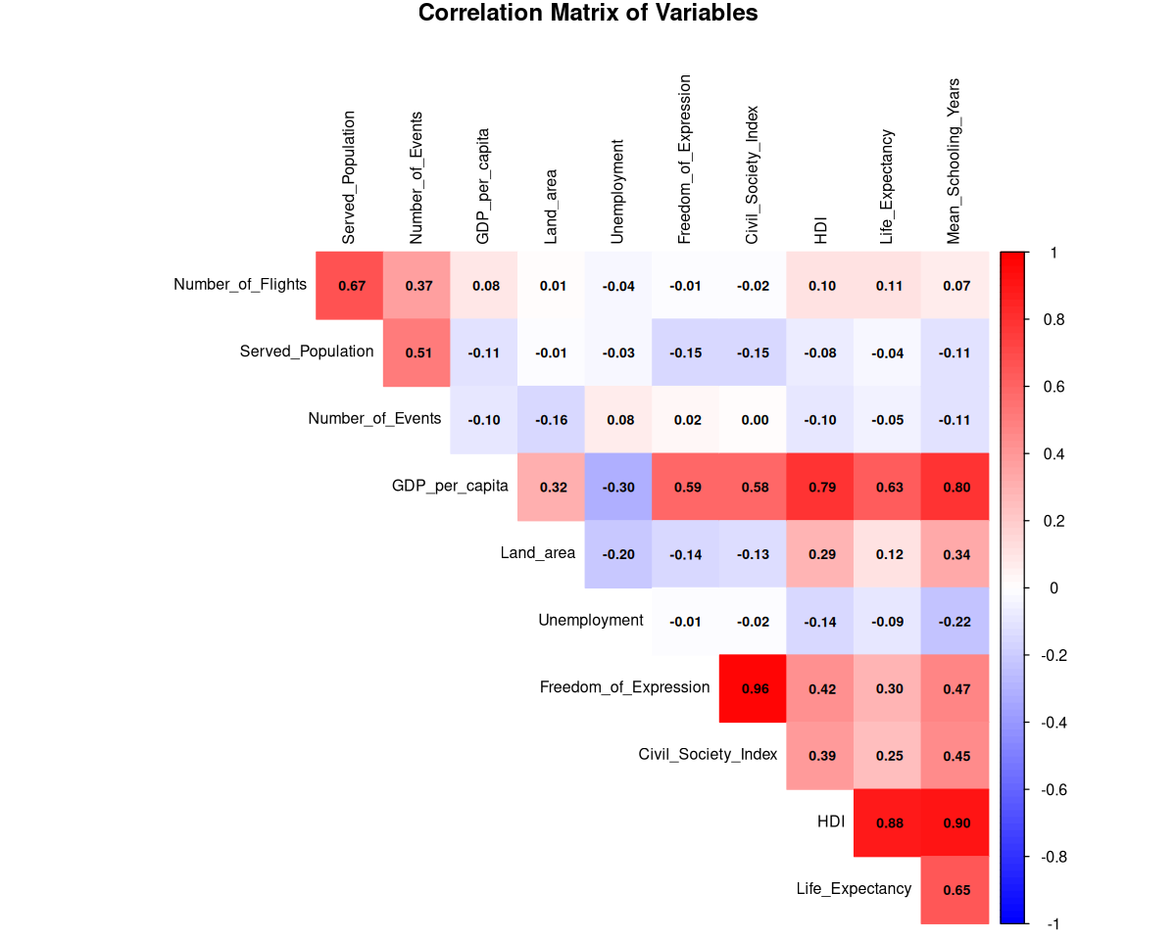
where the log link function transforms expected counts into a linear function of predictors, and standard errors are robust to heteroskedasticity.
Prior to estimation, the dataset was tested for multicollinearity. Several candidate variables, including GDP per capita, average years of schooling, and civil society indices, were dropped from the model due to high variance inflation factors (VIFs), indicating redundancy or strong correlation with retained predictors. The remaining variables were selected based on both theoretical relevance and empirical independence.
In this specification, coefficients can be interpreted as incidence rate ratios: for each unit increase in a given predictor, the expected count of unrest events changes multiplicatively, holding all else constant. This model thus enables a nuanced interpretation of how global infrastructure, specifically air travel networks, relates to urban political instability when embedded in broader economic and institutional contexts.
Results
The Negative Binomial regression results reveal a statistically robust and meaningful relationship between global air connectivity and the frequency of social unrest events across cities. The model accounts for a considerable portion of the variation in protest counts, with a Cragg and Uhler pseudo R² of approximately 0.323 and a residual deviance of 3,164.7 across 2,620 observations. The McFadden pseudo R² of 0.039 further supports moderate explanatory power relative to the null model. All predictors in the final specification are statistically significant at the p < 0.001 level.
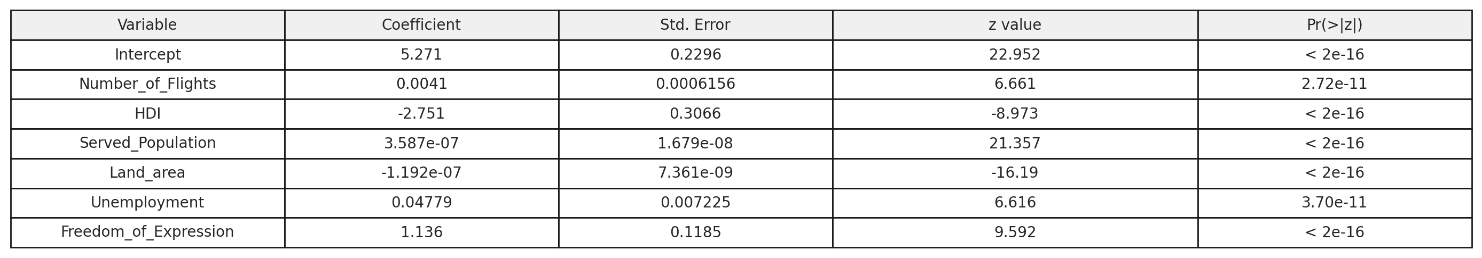
The air connectivity measure, Number of Flights, has a coefficient of 0.0041, indicating that each additional direct flight corresponds to roughly a 0.41% increase in the expected number of protest events, holding other variables constant. Although this marginal impact is small, the cumulative effects for highly connected cities are substantial. The Served Population variable exhibits a strong positive association as well: with a coefficient of 3.587e−07, an increase of 1 million in the population served by nearby airports translates into an approximate 42.1% rise in expected protest frequency. These findings emphasize the infrastructural dimension of protest potential—connectivity facilitates not just economic activity but also social mobilization.
Among the control variables, both Unemployment (0.0478) and Freedom of Expression (1.136) are positively associated with protest intensity. These results align with theoretical expectations: high unemployment often signals economic distress, a common grievance driver, while enhanced civil liberties can make it easier for dissent to be organized, expressed, and reported.
In contrast, Land Area (−1.192e−07) is negatively associated with protest counts, potentially reflecting the spatial dispersion of unrest in geographically larger urban areas or lower population density. HDI (−2.751), included in this model, is significantly negatively associated with unrest, suggesting that more developed national contexts, with better governance and social services, may reduce the need or impetus for disruptive collective action.
Taken together, these results underscore that global air infrastructure does more than move goods and people; it may also act as a conduit for social and political agitation. While the analysis is correlational and cannot establish causality, it provides empirical evidence that protest activity tends to cluster in cities that are not only more connected and visible but also economically and politically complex. Further longitudinal and causal research will be necessary to disentangle these relationships and explore their policy implications.
Limitations and Future Research
Several factors constrain the inferences that can be drawn from this analysis and highlight opportunities for refinement in future work. First, the cross-sectional design and temporal mismatch between variables limit causal claims. While the flight connectivity data reflect 2014 schedules and protest events span June 2020 to April 2025, reducing immediate simultaneity concerns, the single-time snapshot for both variables precludes any assessment of whether earlier connectivity directly influenced later unrest. A panel data or event-study approach would be needed to trace such dynamics over time.
Second, potential endogeneity remains a concern. Politically active cities such as national capitals may attract greater air traffic not only due to economic factors but also their symbolic or strategic significance, such as capital status or media visibility. While the model includes several socioeconomic and institutional controls, unmeasured confounders like policing intensity or internet penetration could bias results.
Third, several key variables carry potential measurement error. ACLED’s protest data may suffer from under-reporting in authoritarian or low-connectivity contexts, especially during information blackouts. Similarly, OpenFlights data may lag real-time changes—particularly in the wake of the COVID-19 pandemic, which restructured air networks significantly after 2020. Additionally, the population dataset used to calculate Served Population is not limited to urban administrative boundaries and includes jurisdictions of varying size and scope. As a result, some residents may be double-counted depending on how overlapping or nested jurisdictions were classified, introducing noise into estimates of airport influence.
Spatial assignment methods also present challenges. Airports and protest events are linked to cities within a 50-kilometer radius, using a “service score” that adjusts for proximity and flight volume. While this approach balances spatial precision with scalability, it may misrepresent airport reach in complex metro areas (such as multi-airport regions like New York–Newark) or in locations where secondary airports play disproportionate roles.
Also, the model’s assumptions might be questionable: the Negative Binomial regression assumes constant dispersion across all cities, but preliminary heterogeneity checks suggest that protest variance may differ significantly by regime type or geography. Future research could explore mixed-effects models, spatial clustering, or zero-inflated alternatives to address these concerns.
Finally, a major constraint on empirical precision stems from the monetization of air traffic data. Comprehensive passenger flow metrics, airport-level enplanement figures, and real-time flight schedules are often proprietary and can cost thousands of dollars to access. These commercial barriers limit researchers’ ability to construct more granular or temporally dynamic indicators of air connectivity. The present study relies on publicly available data, which, while suitable for global coverage, may introduce measurement noise due to missing, outdated, or estimated route information. Access to higher-resolution aviation data would enable more accurate assessments of how mobility infrastructure relates to protest dynamics and would substantially enhance future research in this area.
Overall, these limitations underscore that the results presented here should be interpreted as associational, not strictly causal. Nonetheless, the observed relationships suggest meaningful patterns that merit deeper investigation. Future studies could enhance this framework by incorporating annual flight network changes, high-frequency protest tracking, and disaggregated governance indicators at the metropolitan level.
Conclusion
This study provides empirical evidence that global air connectivity is significantly associated with increased levels of social unrest at the city level. By analyzing a cross-sectional dataset of 2,620 cities across 191 countries using a Negative Binomial regression model, the results suggest that the number of direct flights served by nearby airports are robust predictors of protest frequency. These relationships hold even when controlling for a range of socioeconomic and institutional factors, including population, unemployment, urban scale, civil liberties, and overall human development.
The findings contribute to a growing body of literature on globalization, infrastructure, and political contention. In particular, they underscore that air travel networks are not merely channels of economic integration; they also shape the logistical and symbolic terrain on which modern protest unfolds. Connectivity facilitates not only mobility but also visibility, coordination, and access to global audiences, all of which can amplify local dissent. The strong positive association between freedom of expression and protest frequency further supports the view that infrastructure interacts with political openness to produce distinct urban protest profiles.
While the analysis is observational and does not establish causality, it reveals meaningful spatial and institutional patterns that merit further investigation. Future research could build on these results by incorporating temporal dynamics, network-based measures of city centrality, or qualitative insights into protest organization in connected cities. From a policy perspective, the results highlight the need to integrate social and political risk considerations into transportation and urban planning strategies, particularly in globally networked hubs.
Ultimately, this study advances a novel argument: that the same global infrastructure that enables commerce and exchange can also act as a conduit for unrest. As cities continue to expand their global links, understanding the dual role of connectivity will be essential for navigating the political implications of an increasingly mobile world.
Bibliography
[1] K. Dodson, "Globalization and protest expansion in democracies," Social Forces, vol. 93, no. 4, pp. 1481-1519, 2015.
[2] D. della Porta and S. Tarrow, "Transnational protest and global activism," Rowman & Littlefield Publishers, 2005.
[3] B. Köhler and M. Wissen, "Glocalizing protest: Urban conflicts and global networks," City, vol. 7, no. 1, pp. 59-72, 2003.
[4] J. Walton and D. Seddon, "Free Markets and Food Riots: The Politics of Global Adjustment," Wiley-Blackwell, 1994.
[5] P. Evans, "Counterhegemonic globalization: Transnational social movements in the contemporary global political economy," in Handbook of Political Sociology, Springer, 2005.
[6] C. García-Jimeno, A. Iglesias, and P. Querubín, "Transportation networks and the diffusion of political unrest," American Economic Review, vol. 112, no. 6, pp. 1948-1984, 2022.
[7] S. Tarrow, "The new transnational activism," Cambridge University Press, 2005.
[8] BBC News, "Hong Kong airport protest disrupts flights," Aug. 2019.
[9] M. Castells, "Networks of Outrage and Hope: Social Movements in the Internet Age," Polity Press, 2012.
[10] C. Davenport, "State repression and political order," Annual Review of Political Science, vol. 10, pp. 1-23, 2007.
[11] Varieties of Democracy Institute (V-Dem), "Annual Democracy Report 2020," University of Gothenburg, 2020.
[12] Freedom House, "Freedom in the World 2024: Annual Report," Freedom House, 2024.
[13] Human Rights Watch, "Internet Shutdowns in Ethiopia and Myanmar," 2023.
[14] M. E. Keck and K. Sikkink, "Activists beyond borders: Advocacy networks in international politics," Cornell University Press, 1998.
[15] The Guardian, "Georgia protesters denounce 'Russian-style' foreign agents law," Mar. 2024.
[16] World Bank, "Air Connectivity Index," World Bank Data, 2022.
[17] M. Azedi and E. Schofer, "Global integration and domestic protests," Journal of Conflict Resolution, vol. 67, no. 2, pp. 291-318, 2023.
[18] J. Fisher, "Airport activism: Global climate protests and transportation networks," Environmental Politics, vol. 30, no. 3, pp. 319-342, 2021.

