DATA 118 Project: Crime & Income in Chicago

Introduction to the Dataset
For this project, I will be studying the correlation between poverty and violent criminal activity in ZIP codes across the city of Chicago during 2019. To this end, I have obtained data from the Chicago Police Department on every crime committed in that year (which has been filtered to only violent crimes), as well as federal tax return data from the Internal Revenue Service, which has been further refined to only include ZIP codes within Chicago, in addition to supplimentary data to assist in the calculations.

Data Sources:
- Chicago Police Department Crime Data (2019): Provides detailed information on reported crimes, including the type of crime, location, date, and time. This dataset has been narrowed to focus solely on violent crimes.
- IRS Federal Tax Return Data (2019): Contains income from federal tax filings. This dataset has been filtered to include only Chicago ZIP codes to obtain average income levels and economic data for each area.
- Chicago ZIP Code Population Data (2019): Provides total population estimates for each ZIP code in Chicago. This dataset is used to normalize crime rates and compare population density across different regions.
- Chicago ZIP Code Boundary Shapefile: Contains geographic boundary data for each ZIP code, allowing matching between coordinates in the crime data with ZIP codes present in the rest of the data.

Definition of Violent Crime
For the purposes of this study, violent crime includes the following offense categories as recorded in the Chicago Police Department dataset:
- Assault
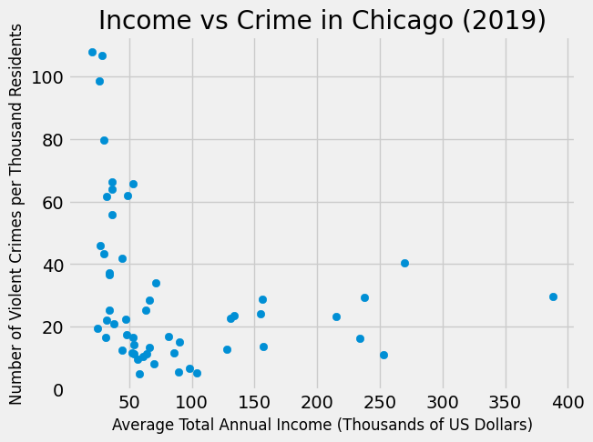
- Battery
- Criminal Sexual Assault
- Sex Offense
- Homicide
- Robbery
- Kidnapping
- Intimidation
- Stalking
- Human Trafficking
These crimes were selected based on their severity and classification as violent offenses under law enforcement standards.

Study Purpose & Collection Method
The data was collected to monitor crime patterns and understand socioeconomic trends within the city. The goal of collecting these datasets is to analyze public safety, identify crime hotspots, and observe economic disparities.
- The crime data is sourced from police reports, making it a retrospective observational study, as it analyzes past crime incidents.
- The IRS data is collected for tax and economic reporting purposes, also making it part of a retrospective observational study since it reviews financial records from a prior year.
- The population data is derived from official census estimates and serves as an important variable for contextualizing crime rates.

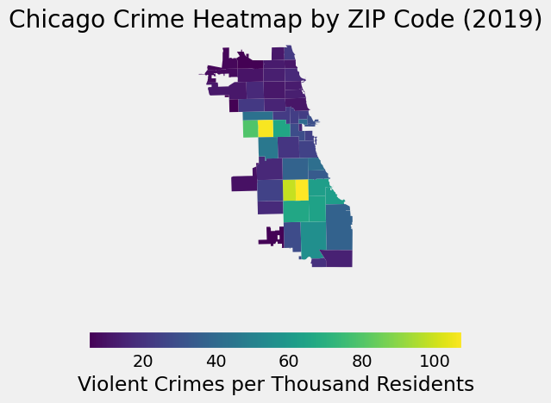
Variables and Observations
The dataset contains multiple variables. Here are a few key examples:
- Crime Data: Geographic coordinates, type of crime, number of reported crimes, and arrest status.
- IRS Data: ZIP code, total income, and number of tax returns filed.
- Population Data: ZIP code, total population.
- Geographic Data: ZIP code boundaries for spatial visualization and matching crimes to zip codes.
The final dataset includes 54 ZIP codes, each containing information on crime, income, and population. However, outliers with low populations will be filtered out.
Sampling Process & Potential Bias
- The crime data is a complete census of reported violent crimes in Chicago for 2019. However, it is still subject to reporting bias, as some crimes (such as domestic violence or crimes in underserved communities) may go unreported.
- The IRS data represents all federal tax returns filed, making it a comprehensive dataset for income-related metrics. However, it may underrepresent certain populations, such as low-income individuals who do not file tax returns or undocumented residents, which could introduce selection bias in poverty estimates.
- The population data helps contextualize crime rates, but changes in population over time or undercounted groups may introduce additional bias.
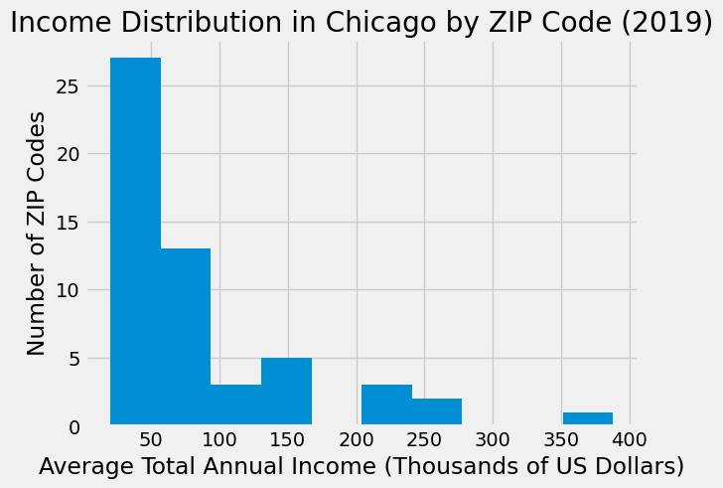
- The geographic boundary data ensures that ZIP codes are correctly mapped, but ZIP code boundaries do not always perfectly align with neighborhood or policing areas, which could affect spatial analysis.
Despite these limitations, the dataset offers a strong foundation for analyzing the relationship between poverty and violent crime across Chicago ZIP codes.

Characteristics of the Sample
The dataset consists of 54 ZIP codes in Chicago, each representing a local crime and income profile for the year 2019. The unit of analysis is the ZIP code, with data aggregated at this level to study patterns of crime and economic disparity.

1. Distribution of Income
The average total annual income across ZIP codes varies significantly. Most ZIP codes have an average income below $100,000, but a few high-income areas exceed $200,000, with the highest-income ZIP codes nearing $800,000, though those have been removed from the sample as outliers as they contain very few people and skew the results.
A histogram visualization of income distribution shows that the majority of ZIP codes fall within the lower income range, while a small number of ZIPs have disproportionately high incomes.

2. Distribution of Violent Crime Rate
Violent crime rates, measured as number of violent crimes per 1,000 residents, also show variation across ZIP codes. Most ZIP codes have crime rates between 10 to 40 per 1,000 residents, but some high-crime areas exceed 60 per 1,000 residents.
A histogram visualization highlights the concentration of crime rates, revealing a pattern where certain ZIP codes emerge as crime hotspots.

3. Summary Statistics
A summary table of key variables (income, crime rate, and population) provides a numerical
breakdown of these characteristics. This table includes measures such as mean, minimum, maximum, and quartiles, helping to contextualize how crime and economic status vary across different parts of the city.
Overall, the dataset presents a diverse range of economic and crime conditions, setting the stage for further analysis on their relationship.
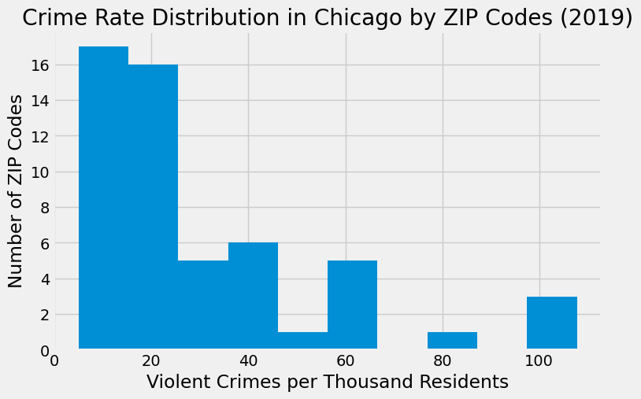
Relationships Between Variables
To explore the relationship between crime and economic conditions, we examine correlations between key variables.
1. Income vs. Violent Crime Rate
A scatter plot visualization with a fitted trend line shows that there is a moderate negative correlation between income and violent crime rate. Higher-income ZIP codes tend to experience fewer violent crimes per 1,000 residents. However, there are some exceptions where high-income ZIPs still report moderate crime rates.
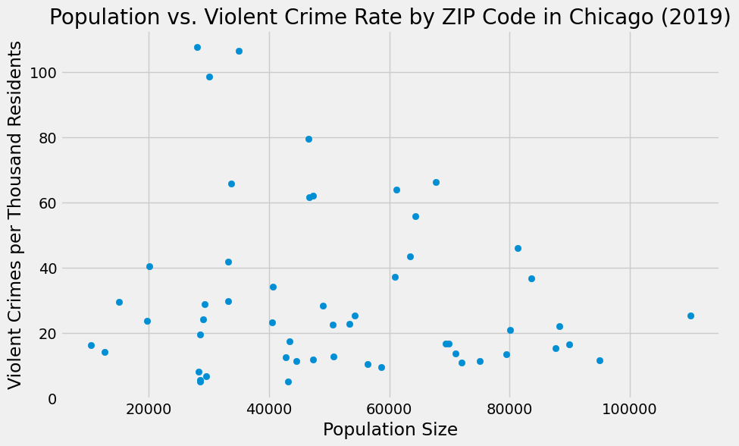
2. Population vs. Violent Crime Rate
Another relationship examined is between total population and violent crime rate. The scatter plot suggests that higher-population ZIP codes do not necessarily have higher crime rates per capita. This implies that crime is not purely a function of population size but may be influenced by additional socioeconomic and environmental factors.
These findings suggest that while income plays a role in crime rates, it is not the only determining factor. Further investigation into other economic and social variables may provide deeper insight.
Hypothesis Test Setup
To further analyze the relationship between income and crime, we propose a hypothesis test.
Research Question:
Do higher-income ZIP codes in Chicago experience significantly lower violent crime rates than lower-income ZIP codes?
Null and Alternative Hypotheses:
- Null Hypothesis (H₀): There is no significant difference in violent crime rates between low-income and high-income ZIP codes.
- Alternative Hypothesis (H₁): Higher-income ZIP codes have significantly lower violent crime rates.

Test Statistic:
Given the nature of the data, we propose using a two-sample t-test to compare the mean crime rates between high-income and low-income ZIP codes. The ZIP codes will be split into two groups based on the median income:
- Low-income group: ZIP codes below the median income.
- High-income group: ZIP codes above the median income.
The two-sample t-test will help determine whether the observed difference in crime rates between these groups is statistically significant.
Assumptions for the t-test:
- The crime rate data for each group is approximately normally distributed or the sample size is large enough for the Central Limit Theorem to apply.
- The two samples have independent observations (each ZIP code is treated as a separate unit).
The hypothesis test will help determine whether the observed correlation is statistically significant and whether income level truly influences violent crime rates in Chicago ZIP codes. Understanding the socioeconomic factors influencing crime is crucial for crafting effective policies that promote both safety and economic growth.

Sources:
- https://data.cityofchicago.org/Facilities-Geographic-Boundaries/Boundaries-ZIP-Codes-Map/gdcf-axmw
- https://data.cityofchicago.org/Public-Safety/Crimes-2001-to-Present/ijzp-q8t2/about_data
- https://data.cityofchicago.org/api/views/85cm-7uqa/rows.csv?accessType=DOWNLOAD
https://www.irs.gov/pub/irs-soi/19zp14il.xlsx
- https://geopandas.org/en/stable/docs.html

